15 September 2024 postcard

Thanks for all your queries and good wishes. Yes, as I should have said in yesterday's postcard, David's digestive tract straightened itself out in time for our nice dinner at Restaurant Anne—David blames it on something he ate.

So we're back on track. The day's excursion was to the Army Museum in the Hotel des Invalides, which also houses an old folks' home for veterans, Napoleon's tomb, a magnificent chapel (from the days when the whole place was an old veterans' home, hence the name), and some current military operations. It's big (it has 11 interior courtyards!).

As usual, we set out about 11:30 am and took the #8 metro to École Militaire (the French military academy, right next door to the Invalides) because we knew the entrance was on that side of the building.

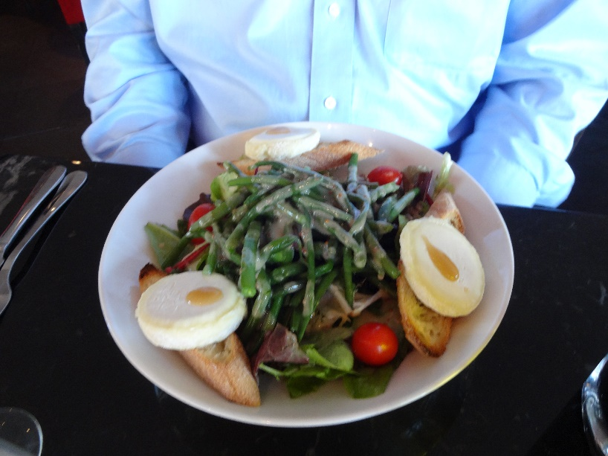

We picked a menu we liked from the wide assortment of nearby eateries. I had a lovely omelet with fries, and David tackled this magnificent salad featuring three medallions of ripened goat cheese on toasts and a healthy portion of cold green beans, drenched in a tasty mustard vinaigrette. The beans were great (he let me have a few); the French pick their beans young and sweet, and they understand what is meant by "tender-crisp."

Then we walked over to the usual entrance to the Invalides—we've been there many times—to find that, drat, that entrance was open only from 2 to 6 pm. Some huge left-over Olympic structure was being removed, and was blocking that entrance. From 10 to 2, you had to go in from the other side, the one facing the Seine down its long esplanade. It was only 1:30 pm, so we set off on the 15-minute walk around the building—I told you it was big.

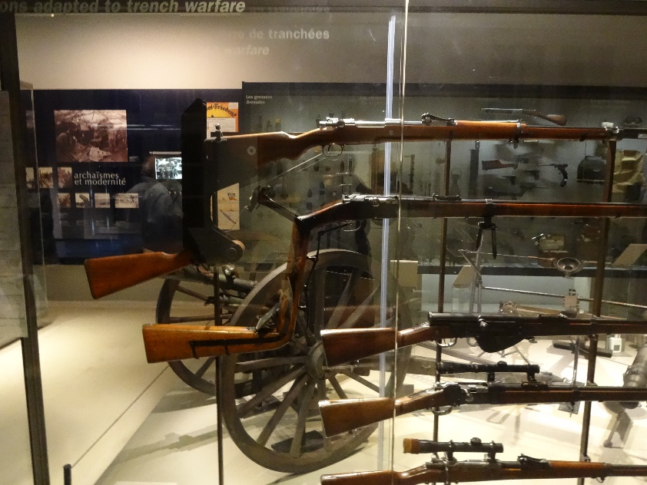

Once inside, though, David was enthralled, and I found enough of interest to hold my attention. We started with the Napoleon section, but David soon decided he's rather do the World Wars, so we walked around to the opposite wing (the hike is much shorter when you only have to circumnavigate the innermost central courtyard) and worked our way chronologically through WWI.

I hope you can make out, in this rather cluttered photo, these incredible periscope rifles, intended for shooting over the lip of a trench while keeping your head safely below it. The two wooden stocks you can see at the left-hand side of the photo correspond to the two uppermost barrels at the right. These were prototypes, and the concept was soon abandoned—aiming by periscope turned out to be iffy, and reloading was difficult. (Back in the Napoleonic section, we'd seen a "rampart rifle" with a barrel fully 8 feet long! Clearly it had to rest on a rampart for any chance of accuracy.

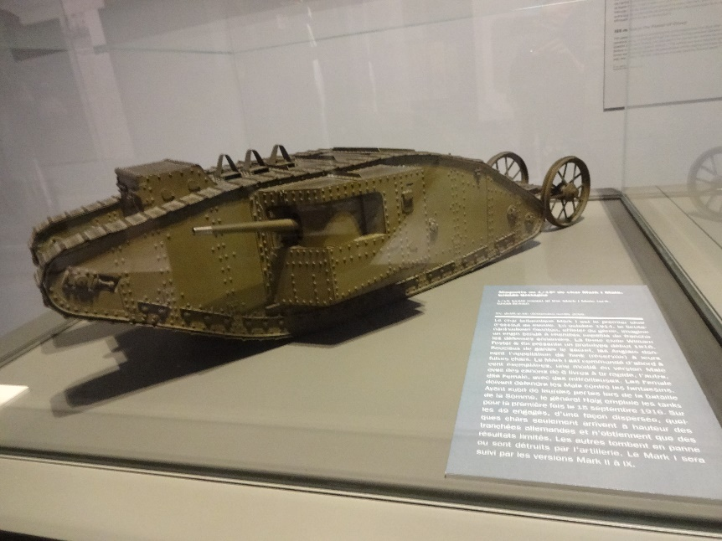

And here's a model of the world's first assault tank, used by the British.

When our feet gave out (about the end of 1918), we headed back to our subway stop and back to the hotel to rest up for dinner. On the way, David's comment was that if you're interested in military history, that place is as good as the Louvre!

Later, we took the same subway trip back to the restaurant, our old friend Le Violon d'Ingres, which is also near the École Militaire.

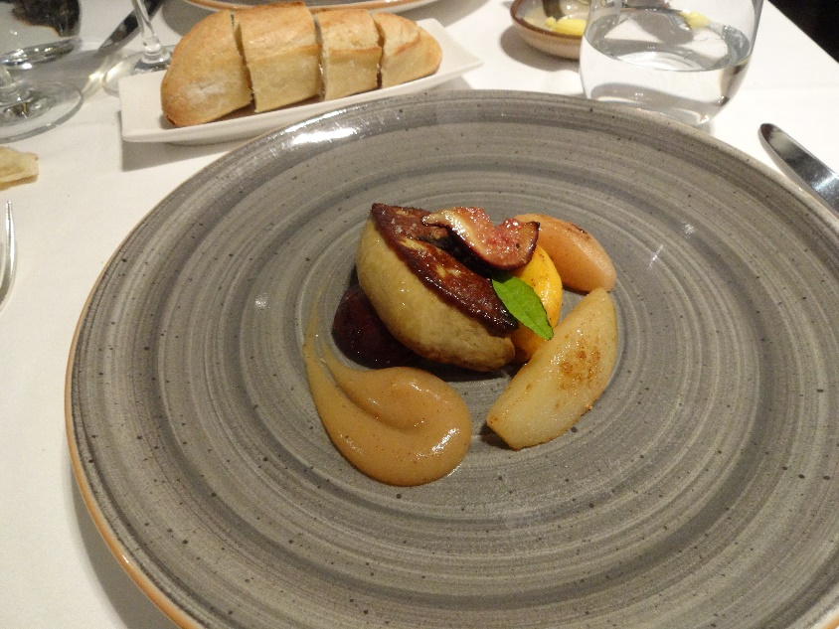Here's the foie gras course of our tasting menu—a wedge of it sautéed and surround by sautéed fruits of the season, apricot, plum, fig, apple, pear, peach, all decorated with a comet of tart fruit purée to set off the richness of the liver.

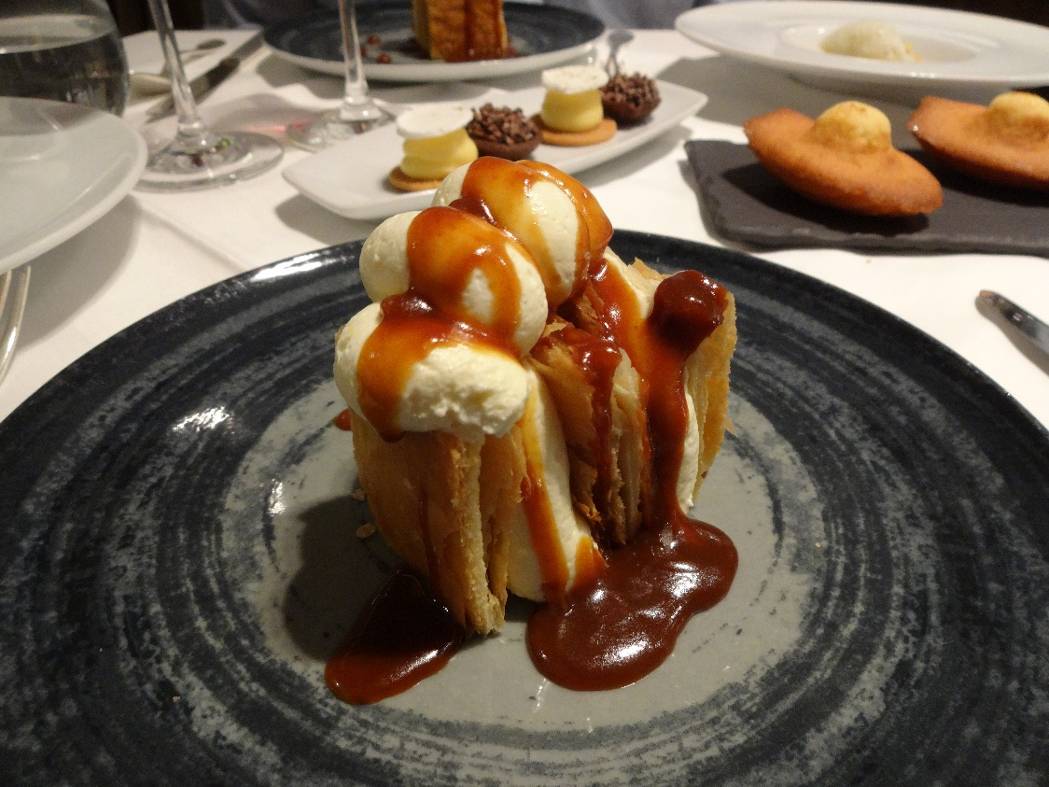And a couple of the desserts with which the table was paved a few courses later.

Front and center, a vanilla "millefeuilles" drizzled generously with salted caramel sauce. In the background, you can see two kinds of mignardises: little chocolate tartlets, tiny cookies topped with lemon cream and meringue disks, and a pair of madeleines. Out of sight to the left was a finely diced salad of mango, kiwi, and pomegranate arils topped with a scoop of lemon sorbet.